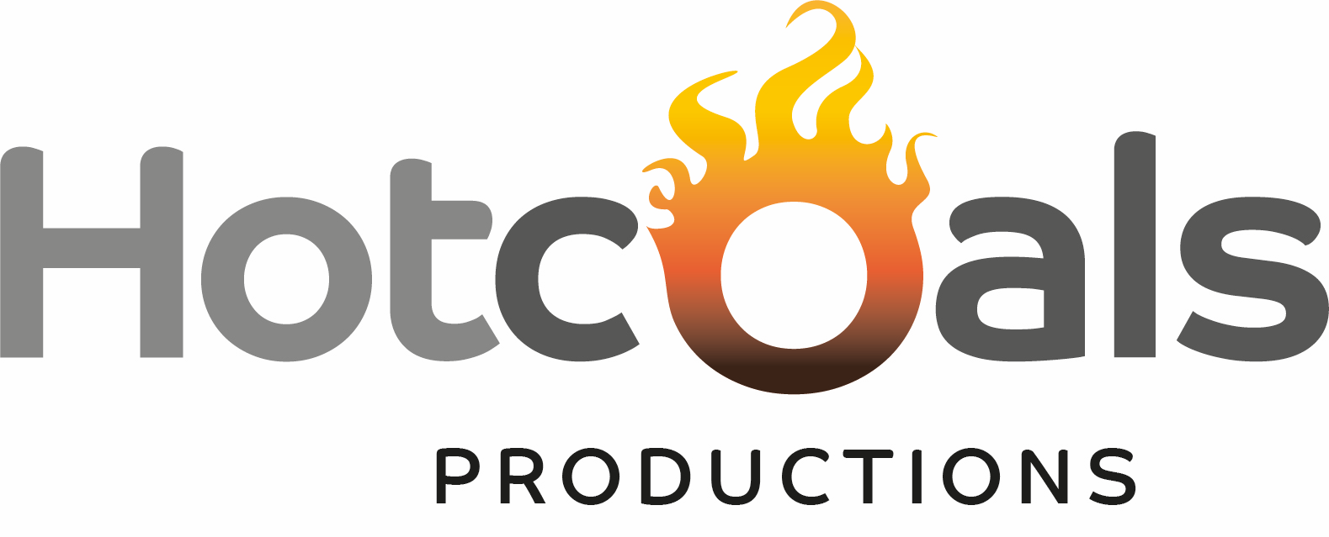

About Us

Hot Coals Productions is an award winning production company making compelling stories in theatre and film. Formed of core members Clare-Louise English and Jo Sargeant.
We at Hot Coals Productions, believe in The Arts, we believe in the power of theatre and film to change the world, but we believe we can do it with a lightness of touch, with beauty and with laughter.
As a company led by 1 deaf & 1 dyspraxic artist, Access is central to the work we create and our unique brand of accessible work in both theatre and film.
Over the years we have created theatre productions delivered to the public via in-house London runs and UK regional & rural tours, and shot an award winning film which is now going to festivals across the globe.
This is a great opportunity to join a very exciting company at a turning point of their development and to create an Access Manager role during a Script Development stage of their project, Talking Bodies.

For more information:
www.hotcoalsproductions.co.uk

What is Talking Bodies?
Talking Bodies is Hot Coals Productions’ latest project, which has just been award Arts Council funding for its first phase of development. The finished Talking Bodies piece will take the form of 6 short films showcased as an immersive promenade installation. During this Script Development phase you will be working with a large group of deaf and disabled artists to develop 11 scripts over the course of 10 weeks, from which the final 6 will be chosen for the next stage.
This is an incredibly ambitious piece and during this stage you will be working alongside, some highly skilled and leading artists in their field. You will have the opportunity to create the Access Manager role, which hopefully, will become a recurring role at each further stage of this project.

About You
We are looking for someone with excellent organisational and interpersonal skills, a passion for the arts and a commitment to lifting barriers faced by Deaf and disabled artists and practitioners within the Arts.
This post is open to Deaf or disabled people with a lived experience and/or applicants who have an in-depth understanding and appreciation of access barriers to working in the arts.

Job Description:

Job Title: Access Manager

Fee and Contract: This is a 12 week project for a total fee of £4680 with possibility of additional hours calculated on daily/hourly rate. We anticipate the workload to be equivalent to 3 days a week .
The contract offered will be one for the provision of services and not an employment contract.

Working Hours: 3 days a week, hours to be negotiated, some flexibility required

Start date: Immediate start

Working location: Working from home (with potential studio work, COVID dependant). You must be set up to work remotely with a good internet connection and webcam. London based preferred.

Closing date for applications: end of day Monday 30th November.

Application process: Please send CV and covering letter (2 pages max) identifying how you meet the Person Specification, and including 2 references, to Hot Coals Productions at office@hotcoalsproductions.co.uk

If you require any reasonable adjustments to the interview or application process please let us know.

Selection process & criteria:
We would like to encourage a diversity of people to apply for this role.

Shortlisting will take place immediately after the deadline and will be matched to the Person Specification. You will be contacted if we wish to invite you to an interview.

The first round interviews will take place w/c 30th Nov and panel will consist of Clare-Louise English and Jo Sargeant and will last 30-40mins.

If you have access requirements we will give you an opportunity to tell us about those before your interview.

Purpose of Role:
The Access Manager will be responsible for facilitating and managing access on our Talking Bodies project at the Script Development phase. They will be liaising with writers, directors, actors, and script mentors, and ensuring the project is complying with COVID guidelines. The Access Manager will report to the Hot Coals management team and will work closely with Core members and guest Artists/Practitioners.

Key Responsibilities:
- Provide a safe and inclusive environment for all artists and guests
- Work alongside Hot Coals core to engage with and uphold best practice approaches to inclusive and accessible practices.
- Consult artists and guests on their access needs and preferred interpreters / support workers
- Booking and contracting British Sign Language - English interpreters and support workers
- Managing invoicing and payments for interpreters and support workers
- Managing and working within the Access budget
- Working with Access to Work where appropriate
- Direct artists and guests towards mental health services if support is required
- Contribute to reporting & evaluation for the Talking Bodies project
- Make sure project is complying with COVID guidelines
- Creating accessible documentation during the project for those involved
- Creating accessible web and social media content.
- Other administrative tasks to support management as agreed with Hot Coals core team.
- Running DBS checks

Person Specification
This role would suit someone who comes from a background of Arts Management, General or Company Manager, Access Support Worker, CSW or Creative Enabler. We are looking for someone with a passion for the arts and new writing, with an interest in theatre and film.

Essential qualities, skills and experience:
- Identify as Deaf or disabled under the Social Model of Disability or have an in-depth understanding and appreciation of access barriers to working in the arts, as well as how these barriers may be addressed.
- A minimum of 3 years relevant arts industry experience
- Experience in working with Deaf and disabled artists
- Up to date DBS (preferably on the update service)
- Excellent organisation and planning skills with proven ability to work flexibly under pressure, to prioritise and to meet deadlines
- Self-motivated and able to work independently remotely
- The ability to work collaboratively and form effective partnerships internally and externally
- Excellent communication skills, both verbal and written. (NB We recognises that this can be achieved by various means, e.g. through a third-party communicator)
- Excellent IT skills across a range of software packages including Microsoft Office
- Basic editing skills
- Experience in problem solving both creatively and pragmatically
- Progressive, open minded and respectful to others
- A can-do attitude

Desirable:
- Conversational fluency in British Sign Language (ideally Level 3 - 6 BSL)
- Knowledge of access, disability and mental health
- Experience working in access within a theatre or Arts setting.
- Understanding of and commitment to equal opportunities, as outlined in the Equality Act 2010
- Understanding of the Access to Work scheme and how to apply
- Knowledge of various Best Practice guidelines within the Arts including Equity’s Guide to Good Practice with BSL in the Arts.
- Ability to think outside the box, to learn as you go and create working systems.

